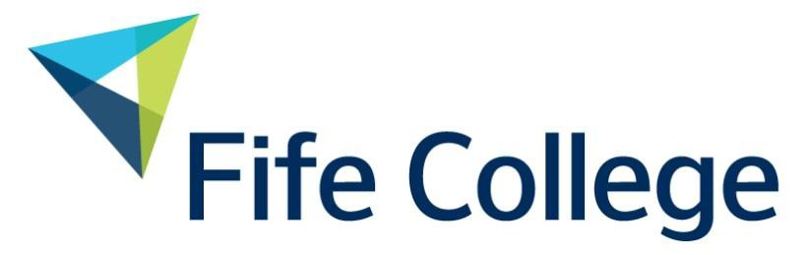

STEM Strategy
Training the talent of today for the world of tomorrow
A commitment to developing Science, Technology, Engineering and Mathematics throughout the College and across Fife

Contents

Introduction 2
National Context 2
Regional Context – Fife Economic Strategy 2017-2027 3
STEM Strategy 4
Aims & Objectives 5
Pledges 6
Outcomes & Impact 7
Delivery Strategy 8
The Future of STEM Skills 11

Introduction

Demand for STEM skills continues to be particularly strong. These skills underpin innovation and are critical to the UK’s ability to compete successfully in high-value, high-growth sectors. The CBI surveys show that businesses are encountering difficulties in recruiting people with STEM skills at every level, from new entrants to train as apprentices, to people with more than five years’ experience of STEM-related work. Employers’ views and priorities around skills – particularly STEM – are clearly shown from their survey results:

- Changing technologies and markets demand rising levels of skills.
- Demand for skills will be strongest in sectors essential for rebalancing, but businesses are concerned that the demand for skills cannot be met.
- People with STEM skills are becoming particularly hard to recruit, and businesses expect these difficulties to intensify.
- The STEM crisis can only be addressed by business and education working together, but government also has an important role to play.

National Context

The Scottish Government’s STEM Education and Training Strategy for Scotland, STEM Second Annual Report March 2020 and Scotland’s Future Skills Action Plan are the drivers for the college to refresh their STEM strategy and action plan, adopting an integrated and coherent vision that is outward focused and drives economic growth and prosperity. Throughout this process, our aims are to ensure STEM provision:

- is of the highest quality and drives excellence across the region
- produces skilled, work-ready, enterprising, digitally fluent and employable students
- generates productive partnerships and relationships with business and local industry
- supports the current and future skills needs of the local, regional and national economy

Giving students, staff and stakeholders an overview of the vision we have created and making specific pledges which we will implement over the coming months and years. This strategy ensures Fife College plays a key and pivotal role in meeting the needs of STEM and related employers in the region and surrounding areas and will inform the college’s planning decisions until 2022, a five-year plan which will be re-evaluated on a one-year cycle.

“Our landmark Climate Change Act raises Scotland’s ambitions and ensures that we are leading the world in the response. STEM will be vital in researching, developing and delivering new approaches to tackle the global climate emergency. Knowledge and awareness of STEM will also be critical in enabling people to engage with the climate change debate and to make informed decisions about the actions that they will take.”

Richard Lochhead MSP, Minister for FE, HE and Science, March 2020

Our strategy and our plans have been and will continue to be shaped by our partners in the region, Fife Council, local industry, schools and universities, who all share our ambition and determination to realise this shared vision.

Regional Context – Fife Economic Strategy 2017-2027

Fife will focus its economic development and employability efforts on supporting the following key sectors:

- Energy and Renewables
- Manufacturing
- Finance and Business Services
- Tourism
- Food & Drink
- Health and Social Care
- ICT
- Construction

While it is difficult to accurately predict the future direction of the economy and the labour market, we can be confident that higher level skills and knowledge of STEM will be increasingly important in the years ahead.

Fife Economic Strategy mirrors Scotland’s Economic Strategy’s four key priorities for sustainable economic growth. With regard to the regional STEM agenda Fife have committed to supporting Scotland’s key sectors and fundamental to this strategy is the “acceleration of Fife’s STEM Strategy.”

Within their strategic partnerships, Fife Council’s Education Department and Fife College have made STEM a priority within their plans to develop vocational pathways.

The objective is a world-class system of vocational education, in which Fife College work with universities, schools, local authorities and employers to deliver learning that is directly relevant to getting a job, as a mainstream option for all pupils in the senior phase of secondary school.

In doing so, we hope to address gender imbalances in learning, and contribute to a significant reduction in youth unemployment by ensuring that what is on offer is relevant to labour market needs and addresses the needs of STEM.

“STEM subjects have never been more relevant than they are today as we face a global climate emergency and the uncertain future arising from the UK’s exit from the European Union. STEM skills drive innovation and growth and are the basis for Scotland’s global reputation for science and engineering excellence. Increasingly important as we position Scotland as a leader in the intelligent application of technologies in the Fourth Industrial Revolution, which are transforming all sectors of the Scottish economy. For all these reasons our STEM Education and Training and Education Strategy, now in its third year, is supporting people of all ages to develop their STEM skills and to broaden understanding of the applications of STEM in the wider Society.”

STEM Education and Training Strategy for Scotland – Second Annual Report March 2020

STEM Strategy

The Scottish Government’s STEM Education and Training Strategy for Scotland October 2017, Fife’s Economic Strategy 2017-2017, DYW Fife and the Government’s Developing the Young Workforce: Scotland’s Youth Employment Strategy December 2014 all make reference to the STEM skills gaps. These documents and sector leading groups are all key enablers in the quest to formulate workable and sustainable solutions to this lack of knowledge and skills students have in STEM related subjects prior to moving into employment. Cognisance of STEAM has been factored into Fife College’s STEM Strategy; however the UK and Scottish government’s priorities, at local and national levels, is the STEM agenda and regional strategies and commitment to resolve this UK wide issue. These aforementioned issues have a serious and detrimental impact on regions and countries, current and future, economic growth and development. We will address these with the following model.
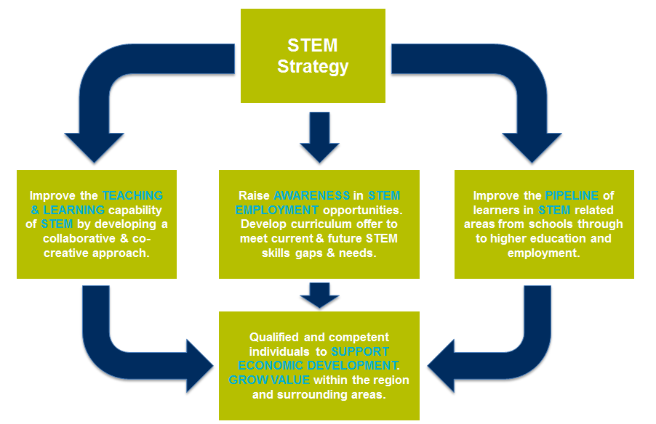

The STEM Strategy provides a robust framework, clarity of purpose and a coherent approach to the provision. Importantly, the STEM strategy strengthens existing provision and provides the college with the capability to deliver education and training in new and emerging technologies that meets the needs of key regional and national industry sectors, preparing students for jobs that do not currently exist. The STEM strategy is an evaluative process which enables the college to effectively identify demand in key sectors and to assess the suitability, scalability and sustainability of existing and new provision.

Aims & Objectives

Our vision is that by 2027, Fife will be a thriving and innovative region with Science, Technology, Engineering and Mathematics (STEM) driving the region’s growth, productivity and future sustainability.
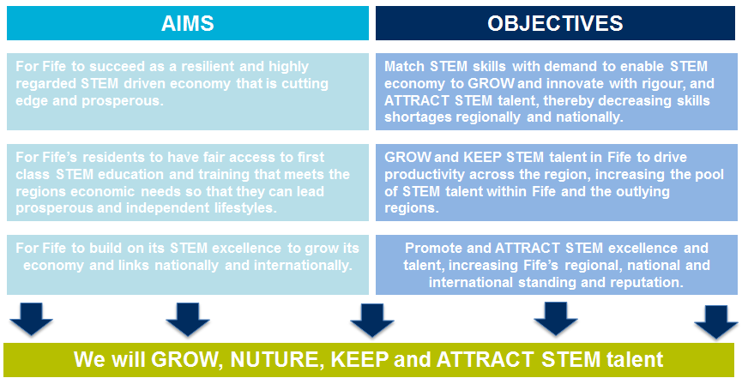

Pledges

We have a responsibility to support the economy across the region with staff that possess the right knowledge and transferable skills to meet labour market needs. It is these duties that the STEM strategy and pledges are designed to address.

Our focus over the next 5 years is manifested in the following pledges which support our commitment to foster a culture of entrepreneurship, innovation and enterprise in STEM.
We will:

- Commit to building a strong STEM capability for the regional economic priorities, particularly emerging and high value industrial and commercial sectors.

- Ensure that STEM is given prominence and status across the College, the community and region.

- Create an education and training environment that delivers the best in STEM learning and teaching at every stage of lifelong learning and development.

- Promote, support and deliver STEM progression and careers through close collaboration with schools, partner universities, employers and other stakeholders.

- Provide the capacity and capability in STEM to enable employers to meet business objectives and the region’s economic priorities.

- Contribute to raising levels of STEM numeracy, literacy and employability skills across the college, the community and the region.

- Build understanding, knowledge and expertise of STEM subjects with staff to support a sustainable portfolio of provision across all faculties.

- Take a lead role in the region and wider industries to raise awareness and attract under-represented groups, such as women, into STEM related industries and education.

Outcomes & Impact

Aligned to Fife College’s Key Performance Indicators, the STEM Strategy is
aimed at getting the right people in the right place with the right skills. This requires Key Performance Indicators that measure against our Economy, Education and Region.

In addition to operational and strategic measures for Fife College and Fife Region, progress and impact will also be measured relative to other regions within Scotland which have similar industrial structures and similar strengths in relation to STEM sectors.

All information will be reported on through the regional STEM strategy group which will be
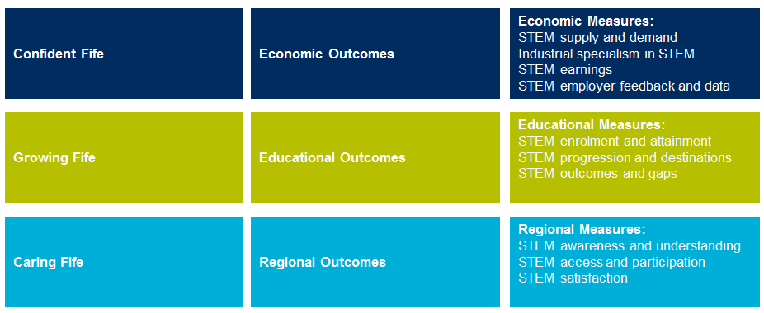
jointly chaired by Fife College and Fife Council Education Directorate.

Delivery Strategy

The College’s STEM strategy identifies 6 specialist curriculum clusters where Fife College in partnership with the regional education authority can develop competitive advantage. These provide the college with a clear framework to signpost, strengthen and progress Fife College’s existing STEM provision. These will also help us to develop the capability to deliver new education and training in emerging technologies to meet the needs of the local industry. Underpinning all of these will be the college wide development of Applied Mathematics, Science, Project Management and cross cutting themes of Innovation, Enterprise, Health and Safety, Technical Literacy, Progression, Employability and Digital Skills and Technologies.

Fife College’s STEM strategy identifies the College’s competitive advantages as:

- Advanced Engineering, Renewables, 4IR, Digital Manufacturing & Automated Systems
- Design, Digital and Creative Technologies
- Computing and Business Analytics
- Sustainable Construction and Energy, Utilities and Emerging Technologies
- Health, Wellbeing and Integrated Care
- Agri-Tech, Food and Drink & Environmental Technologies
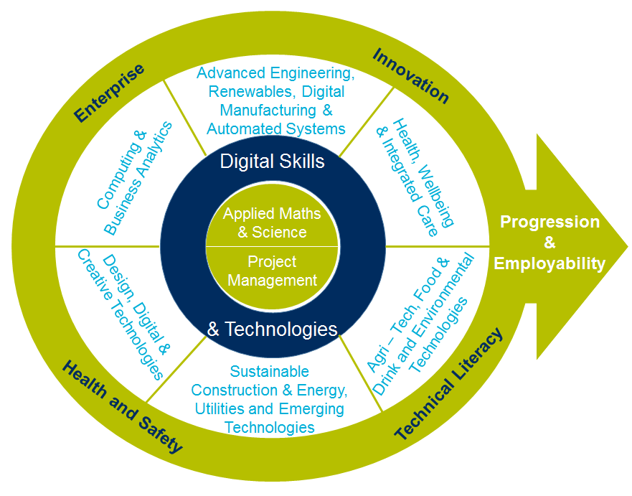

These specialisms are underpinned by transferable and practical skills along with critical competencies as described below:

- Curiosity and creativity
- Interpretation and evaluation
- Observation and inquiry
- Critical thinking and problem solving skills
- Technical and technological knowledge
- Maths, financial literacy, data and statistical confidence
- Innovation and strategic thinking
- Team work and collaboration
- Entrepreneurial Mindset – Entrepreneurship and Innovation

Fife College will focus on:

Advanced Engineering, Renewables, 4IR, Digital Manufacturing & Automated Systems
Future trends for the region indicate that manufacturing output will increase. The College will position itself as a centre of excellence for engineering and advanced manufacturing by investing in technologies such as Robotics, AR/VR, CAD/CAM and control systems and expand its offer to include more higher education provision. These developments will contribute to the local skills plan to invest in and attract high value-added engineering and manufacturing industries to the area. The team works in partnership with external stakeholders to identify local, regional and national skill needs, and seeks to help provide opportunities for students whilst supporting local, regional and national employers and industry. The renewable energy sector continues to expand in Scotland, with increased demand for energy predicted to grow by more than 50% by 2035. The £2bn Neart na Gaoithe offshore wind farm infrastructure project will create 13,900 person years of employment across its construction and operational phases, in total over 2,000 engineering jobs for Scotland over a four-year construction period will be created. Despite a projected contraction in Manufacturing to 16,400 jobs in 2024, the sector is expected to provide over 10% of total jobs in Fife in 2024.

Design, Digital and Creative Technologies
The College will support the growth of the local digital economy by developing and providing training for companies and individuals in technologies such as cyber security, website development and programming, e-commerce, cloud and mobile technologies, network and systems support and digital imagery and processing. Between now and 2020 the number of digital tech professionals in Scotland is forecast to grow by 1.91% per year to 84,000. The sector employs 73,000 people, primarily in high value jobs and makes a direct contribution of £3billion per year to the Scottish economy.

Computing and Business Analytics
Projected growth in the digital technology sector in Fife and the surrounding areas to 2022 is 36%. The Computing and Business Analytics cluster will focus on the applications of cloud computing, information and communication technologies and their applications including cyber security, games development, smart systems and networks, as well as big data, Internet of Things and Artificial Intelligence.

Sustainable Construction and Energy, Utilities and Emerging Technologies
The College will work closely with local industry to support their future skills and training needs through the establishment of innovative learning programmes and will focus on areas such as design and maintenance of buildings, materials performance, construction technology and processes, energy resource and maintenance, operation and efficiency and other new and evolving technologies such as BIM. Training programmes will be developed to support green energy and sustainable construction methods and technologies. Sustainable Construction and energy effectively plays a lead role with staff being trained in these specialist areas do deliver innovative and sector leading curriculum to the students. The construction sector is forecast to make the largest contributions to GVA growth between 2016 and 2024 in Fife, increasing by £92 million.

Health, Wellbeing and Integrated Care
The College has a reputation for excellence and success where courses combine academic study with practical, hands on experience, designed to fully enhance career and employment prospects across a wide and diverse range of fields. Beyond employability, courses also provide an excellent foundation for learners looking to advance their academic studies, either within FE or HE up to degree level. The health and social care sectors are forecast to make a large contribution to GVA growth between 2016 and 2024 in Fife, increasing by £86 million. Health and social care is projected to have the highest levels of jobs in 2024 (25,500 jobs). Health and social care provides over 11,000 more jobs than the next largest Key sector in 2024, equivalent to a 28% share of total employment in Fife.

Agri-Tech, Food and Drink & Environmental Technologies
The college will look to supplement traditional trades with a greater technology based focus on new and emerging technologies currently being adopted be the food and drink sectors. The College will work in partnership external stakeholders to position itself as a centre of innovation and facilitator of professional development activities and events for the agri-tech and food and drink industries. The College will build on its current portfolio offerings to promote new technologies and techniques to the wider industry and develop and deliver bespoke training courses as well as a programme of industry talks and CLPL events.

Applied Mathematics & Science
The College will promote and embed mathematical and scientific skills across the curriculum by drawing on the expertise of staff and industry. The College will seek to ‘STEM enhance’ those aspects of the curriculum that have less core STEM through cross-curricular links and projects. We will ensure that our teaching and learning of mathematics is strengthened by contextualisation. It is vital that the learning and teaching of Mathematics and Science are contextualised and supported by real and relevant industrial and business applications.

The entire STEM strategy will be supported by a new college wide approach to STEM education and training. The areas of focus highlighted above will become high profile themes for Fife College through physical spaces and inter-disciplinary curriculum.

The Future of STEM Skills

A roadmap approach to STEM skills development is needed to anticipate in a timely manner the skills shortages and future needs. The proposed T2K (Trends to Knowledge): STEM Skills Road Mapping model envisages a collaborative approach that operates as an ecosystem, bringing together education and training providers with business and industry, to assess technology and social trends in order to predict and guide the development of new knowledge and STEM related skills provision as shown below.
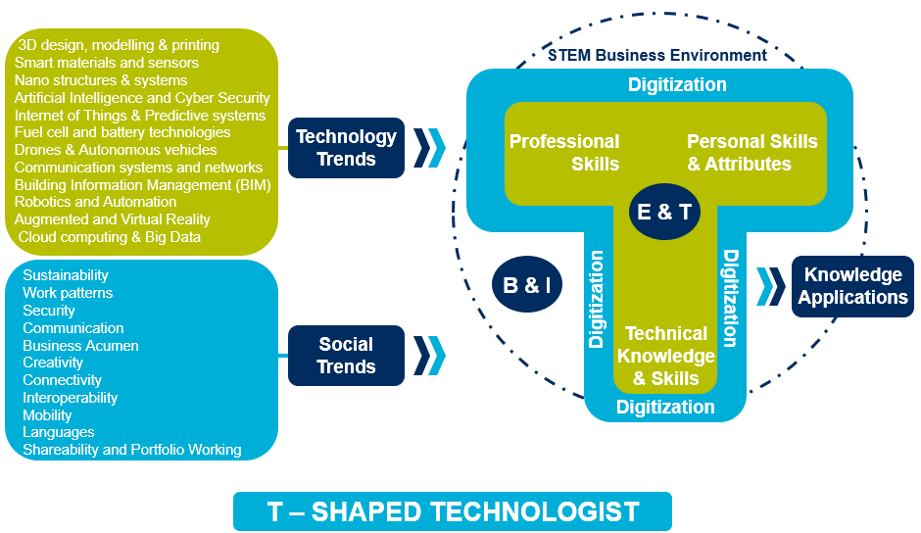

It presupposes the need to develop T-Shaped skills and competencies in students and learners in a balanced way that combines discipline-specific technical knowledge with professional and personal skills and attributes (T-Shaped Technologist report, STEM Foundation 2014). It also assumes a shared responsibility between education and training providers, and, business and industry to identify new and emerging trends to anticipate and thus, update the STEM education and training provision.

This is the model Fife College plan to expand into all curriculum areas and integrate review points in the evaluation process to ensure STEM skills are integrated into everything the college does.

Skills 4.0 – A Skills Model to Drive Scotland’s Future 2018 also needs to be carefully considered in conjunction with the STEM agenda as the skills required for the workforce of the future require a combination of STEM, social intelligence, Innovation, Self-management and resilience.

