Multiple Sclerosis (MS)  Scholarship | 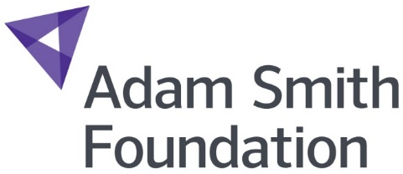
Note of Interest

Student Name: |  | Date of Birth: |  | Age:

Course Title:

Student ID Number: | Curriculum Manager:

Please tick appropriate boxes to confirm you have submitted confirmation of your diagnosis:

 | Yes |  |  | No

The Adam Smith Foundation requires this information in order to assess your eligibility for this scholarship. The information provided will be stored on electronic and paper files, held securely and may be shared with the donor/sponsor for this award. Please refer to the Student Privacy Notice for details on how we process your personal data. This can be found on the college website.

Declaration

I declare that the information given on this form is both true and full and that the afore mentioned students is aware of this nomination.

Signed: . . . . . . . . . . . . . . . . . . . . . . . Date: . . . . . . . . . . . . . . . . . . . . . . .

The closing date for Note of Interest forms to be submitted is Wednesday 13th February 2019 at 12 noon. Please ensure that all details are filled in correctly and send to scholarships@fife.ac.uk. Alternatively you can hand it into a College reception addressed to Gaynor Jamieson, Trust Fundraiser at Fife College. All forms must be received within the closing date to be considered.

