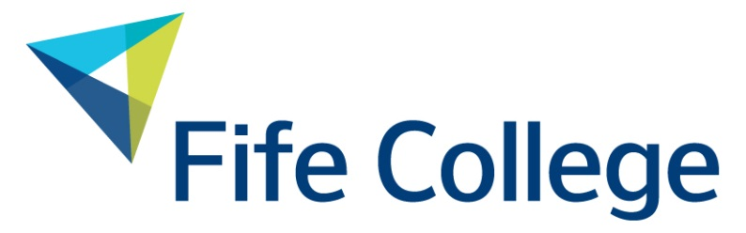

Slavery and Human Trafficking Policy Statement

Statement at End of 2019/20 Financial Year (ending 31/7/20)

Policy Number | FCP2.20
Version Number | 4
Status | Approved
Approval Date: first version | 1 December 2016
Approval Date: second version | 19 February 2018
Approval Date: current version | November 2020
Approved by: | Chief Financial Officer
Responsible for policy: | Procurement Manager
Responsible for implementation: | All Staff
Date of last review: | October 2020
Date of next review: | November 2021
Equality Impact Assessed | 02 November 2018

Document Change History

Document  Version | Section  (No. or Heading) | Description of change(s) | Date of change
4 | All | Full review – minor changes made:  Update of hyperlinks to documents | 16.10.20
3 | All | Full review – minor changes made:  - Update of hyperlinks to documents | 10.10.19
2 | All | Full review – Job titles updated and minor amendments made to wording and formatting.  Reference to CEL removed. | 14.01.19
1 | All | Full review – minor changes made:  - Update of action taken in 2017 including Electronics Watch membership | 16.11.17

Contents

1 Introduction 4
2 Our Categories 4
3 Our Policies on Slavery and Human Trafficking 5
4 Training and Awareness 5
5 Our Plans for the Future 5

1 Introduction

Fife College was created on 1 August 2013 by merging Adam Smith College and Carnegie College and elements of the Scottish Rural College in Fife. A new Fife College creates an opportunity to enhance further education in Fife as an enabler of economic development. It puts learners first to support the ethos of transforming the lives of learners, enabling them to fulfil their social and economic potential.

The College combines first-class facilities, expert teaching and a wide range of courses suited to the needs of local and national commerce and industry. Fife College delivers learning in ten campus hubs across Fife, and a further series of local learning centres. This facilitates accessible, localised and easy-to-reach learning provision in the Fife community.

Fife College delivers over 1,000 courses to over 20,000 students, ranging from introductory/access-level, through vocational, craft and intermediate level, to first degree and graduate programmes.

Fife College is committed to acquiring goods and services for its customers without causing harm to others. In doing so, Fife College is committed to supporting the UK Government’s Action Plan to implement the UN Guiding Principles on Business and Human Rights.

This statement demonstrates our commitment to the Modern Slavery Act 2015 by informing our students, staff and the public about the steps Fife College has taken during the last financial year, ending 31st July 2020, regarding its policy with respect to modern slavery, human trafficking, forced and bonded labour and labour rights violations in its supply chains.

The annual turnover of Fife College is above the threshold for businesses required to publish a statement under the Act.

2 Our Categories

Fife Colleges supply chains mainly fall under six categories, which are:

- Estates Goods and Services
- ICT Equipment and Services
- Professional Services
- Library Resources
- Laboratory Consumables and Equipment
- Human Resources

The principal categories which carry risks are office supplies, laboratory consumables,
ICT equipment and some estates services, such as cleaning and waste management services.

3 Our Policies on Slavery and Human Trafficking

We are committed to ensuring that there is no modern slavery or human trafficking in our supply chains or in any part of our business. Our policies reflect our commitment to acting ethically and with integrity in all our business relationships and to implementing and enforcing effective controls to ensure slavery and human trafficking is not taking place anywhere in our supply chains.

Fife College have embedded sustainable procurement practice throughout its Procurement Policy and Procedures Manual, to which we are committed.

APUC (Advanced Procurement for Universities and Colleges) Limited is the procurement centre of expertise for all of Scotland universities and colleges. APUC exploit opportunities for collaborative procurement. Collaborative tenders are led or jointly managed by APUC on behalf of institutions by working with other purchasing consortia across the UK where it adds value by doing so. Fife College is a member of APUC and currently utilise APUCs managed contracts which cover some of the categories listed above. APUCs Slavery statement can be found here.

Fife College’s Procurement Team currently utilises and is committed to the APUC Supply Chain Code of Code to underpin all tendering activity and supplier adoption.

To assess our suppliers’ compliance with the Code, APUC have developed a web-based assessment tool (SUSTAIN) linked to the contracts database containing contracts/agreements used by the whole sector. The website assesses suppliers at three achievement/compliance levels in social, ethical, economic and environmental areas. The tool enables contract managers to view the status of their suppliers, and for sub tier suppliers to be linked and then assessed.

APUC is a Founder Member of Electronics Watch, an independent monitoring organisation working to achieve respect for labour rights in the global electronics industry through socially responsible public purchasing in Europe. APUC’s Head of Development & Sustainability also sits on the board of Electronics Watch. In January 2017, APUC became the first full consortium member of Electronics Watch, whereby all members have full access to Electronics Watch benefits.

4 Training and Awareness

Fife College Procurement Staff have been trained on Modern Slavery Awareness.

APUC have established a Sustainable Procurement Leaders Group, which Fife College are a member. This group considers all key issues related to sustainable procurement and ways to increase and improve sector awareness.

5 Our Plans for the Future

Fife College expresses its commitment to better understanding its supply chains and working towards greater transparency and responsibility towards people working in them.

Working with our Suppliers, we can map out those supply chains which represent a medium to high risk of modern slavery, human trafficking, forced and bonded labour and labour rights violations.

As part of our initiative to identify and mitigate risk, Fife College commit to:

- Identify and assess potential risk areas in our supply chains.
- Mitigate the risk of slavery and human trafficking occurring in our supply chains
- Monitor potential risk areas in our supply chains.
- Protect whistle blowers and report unethical conduct.
- Where possible, build long standing relationships with our supply chains to ensure these entities have and follow suitable anti-slavery and human trafficking policies and processes.

This Statement has been approved and published by Fife College Board of Governors and will be reviewed at least once annually.

Signed:

Date:

