Fife College Corporate Parenting Plan
2021-2024

Policy Number | FCP2.28
Version Number | Four
Status | Approved
Approval Date: First Version | 11 May 2016
Approved By: First Version | Senior Management Team
Ratification Date: Second Version | 16 May 2018
Ratified By: Version Two | Dorothée Leslie – VP: Academic Strategy
Ratification Date: Third Version | September 2018
Ratified By: Third Version | Dorothée Leslie
Approval Date: Current Version | 2 November 2021
Approved by: Current Version | Vice Principal Academic Strategy
Responsible for Policy | Manager: Admissions, Employability and Custormer Services
Responsible for Implementation | Manager: Admissions, Employability and Custormer Services
Date of Last Review | November 2021
Date of Next Review | November 2024
Equality Impact Assessed | Yes

Document Change History

Document  Version | Section  (No. or Heading) | Description of change(s) | Date of change
5
4 | All | Complete revision of document | October  2021
3 | All | Complete revision of document | Sept 2018
2 | All | Changes made throughout document on recommendations from Who Cares? Scotland | May 2018
1

Contents

1 Introduction 4
2 Corporate Parenting 4
2.1 What is a Corporate Parent? 4
2.2 National Context 4
Fife College Corporate Parent Plan 2018-2021 – Priority Areas 6

Fife College Corporate Parent Plan 2021 – 2024

Context Statement

1 Introduction

Fife College wishes to encourage more applications from care leavers and anyone who has been in care or is cared for by a local authority. Fife College is committed to recruiting students from a diverse range of backgrounds.

2 Corporate Parenting

2.1 What is a Corporate Parent?
A corporate parent is an organisation or individual who has special responsibilities to looked after children and care-experienced young people. ‘Looked after children’ are children in care provided by the state – a group that includes:

- those in residential care
- those in foster care
- those in kinship care
- those who are looked after at home with social work involvement.
A corporate parent is intended to carry out many of the roles a parent should. They may not be able to provide everything a loving parent can, but they should still be able to provide the best possible support and care for the children and young people.
The concept is intended to encourage people and organisations to do as much as they can to make sure children and young people feel in control of their lives and able to overcome the barriers they face.

2.2 National Context

Research confirms that care-experienced young people are much more likely to face poorer life experiences.

We know that some care-experienced young people do achieve positive outcomes. Unfortunately, however, for most care-experienced young people, the outcomes are much less positive, and can result in lower educational attainment, significant under achievement and life chances that are largely reduced.
Many think that care leavers get the same chances as all other young people to get a job or go to college, so that they can work towards their dreams. The reality is, the opportunities may be there, but these young people cannot always sustain them as they are still dealing with the emotional impact of being brought up in care. They need continued support to take advantage of these opportunities.

Young people in care are just like all other young people – except they also need to deal with being separated from their parents, being judged for living in a children’s home, and being viewed as ‘different’ because their families cannot look after them. It is unsurprising that, after these experiences, their outcomes in life can be much poorer than their non-care peers.
This also relates to the national agenda of Getting it Right for Every Child and Developing Scotland’s Young Workforce where the heart of this is supporting our young people.

The College as a Corporate Parent in accordance with Section 58 of the Children and Young People (Scotland) Act 2014 must focus on the safeguarding and promoting the wellbeing of care-experienced students through its corporate responsibilities which are as follows:

- Be ALERT to matters which or which might, adversely affect the wellbeing of an eligible young person;

- ASSESS the needs of eligible children and young people for any services or support provided;

- PROMOTE the interest of eligible children and young people;

- Seek to provide children and young people access to those OPPORTUNITES;

- Take appropriate action to help eligible young people ACCESS those
opportunities; and
- Keep their approach to corporate parenting under constant review, seeking out IMPROVEMENT wherever possible.

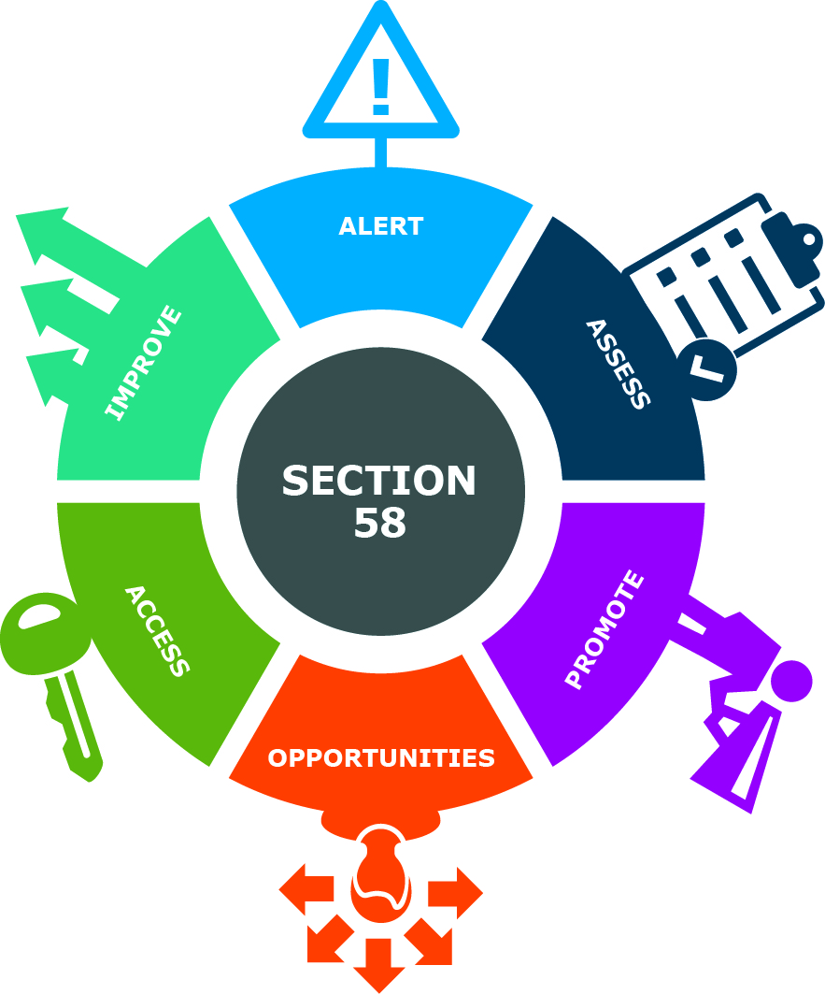

Fife College Corporate Parent Plan 2021-2024 – Priority Areas
Priority Areas 1 – 6 have been taken from the Fife Council Strategic Improvement Plan for Corporate Parenting.

Priority Area 1.
We will be alert to matters which may, or may not, adversely affect the wellbeing of care-experienced young people and care-leavers.
How will we achieve this? | Achieve outcome by | Lead responsibility | How will we evaluate our progress? | Expected Outcomes
Digital skills are an integral part of how we live and work and with the shift to hybrid learning and working, we will equip our students with the necessary skills, tools and confidence they need in order to learn and work anytime, anywhere. Care Experienced students are provided with additional support, the option to borrow Fife College devices and one to one sessions if required to use digital technology.  Continue to develop the effectiveness of current College data management systems to collect and use data on Care Experienced students.  Create reports to measure attendance and achievements of care experienced students. | 2021-2024  Start of every new term. | Care Experience Team  nclusion  Registry and Data Manager  Care Experience Team | Monitor the number of devices borrowed and uptake of support.  Numbers of students self-declaring at interview.  Record number of issues that have been identified and actions taken.  Record referrals and monitor. | Digital inclusiveness for all students.  Increased engagement and productivity.  Curriculum better-informed of status at interview improving uptake and retention.  A deeper understanding of where and when students require support.
Liaise with current Fife projects, including fostering networks and Social Work, as informed through the Fife Corporate Parent Board.  Work with the Developing the Young Workforce co-ordinator in Fife High schools and Fife Council Social Work team to promote College to school leavers and harder to reach Care Experienced individuals. Monitor engagement through transition. | 2021-2024  On-going | Care Experience Team  CPAG  Care Experience Team | Review and record the number of forums actively partnering the College.  Collate transition documents and monitor statistics through REMS. | Being better informed regarding current issues that may be affecting the Care Experienced students.  Up to date information from the schools on support needs to enhance transitions.  Smooth transition and additional support in place for students before they start college. Expect increase in retention rates.
Secure students’ permission to share information with Fife College staff through consent forms.  Monitor the new Request to Share Information box on the new funding forms.  Hold events where students are encouraged to bring their Parents/Guardians/Carers along. | 2021-2024  Term start dates.  2021-2024  Term start dates.  2021-2024  Before term starts. | Care Experience Team  Funding team  Care Experience Team  Guidance  Champion Group | Record number of students completing form.  Check to see whether this option is being used at each new intake.  Collate figures on those attending events. | Improved knowledge of issues which may adversely affect the wellbeing of the CE student.  A more efficient service to make funding as fast as possible to ensure it is in place for start of courses.  Building connections and communication to help students overcome their fear of entering college buildings by being supported by someone familiar to them.
Continue to produce monitoring reports to ensure Care Experienced students are being fully funded and supported during their College journey. | 2021-2024 | Funding Team | The SFC have introduced further data fields to the FES system to capture Care Experienced students background history to ensure they are fully supported during their time in college. | More Care Experienced students benefitting from the Care Experience Bursary.
Survey all Care Experienced students on a regular basis to identify needs. | 2021-2024  Quarterly | Care Experience Team | Monitor number of Care Experienced students who have engaged.  Where possible, use the wellbeing indicators ‘GIRFEC’ to support data analysis. | Improved knowledge, awareness, and engagement with Care Experienced students in college will allow us to adapt our service to the needs of the students.

Priority Area 2.
All Corporate Parent partners will assess the needs of those children and young people for services and support that they provide.
How will we achieve this? | Achieve outcome by | Lead responsibility | How will we evaluate our progress? | Expected Outcomes
Implement the Procedure on Assessing Students’ Personal & Social Support Needs, including Social Support Plans, for care-experienced students.  Create a survey asking students what support they would like from the college. | 2021-2024  2021-2024 | Wellbeing and Support Manager  Inclusion  Care Experience Team, Guidance  Inclusion, FCSA | Monitor the surveys and the uptake on appointments and plans executed.  Collate the survey results and action any points raised. | Improved level of support to Care Experienced (and other ‘vulnerable’) students to reduce social barriers to education.  Student led support in areas they deem necessary.
Hold events where Care Experienced students can come together, to increase comfort levels and likelihood of attendance at times when we know retention is lower. | 2021-2024  On-going | Care Experience Team  Guidance  Champions Group  FCSA | Evaluate through student feedback at end of events. | Highlighting areas of concern and acting before this influences retention figures.
New procedures to ensure routine transfer of support information as soon as student’s consent secured | 2021-2024  Start of term | Inclusion team | Monitored through REMS. | Identifying support needs and Care experienced status at the start of the course to increase retention and reduce stress for students at the start of term.
Maintain staff training and promoting awareness levels.  Continue to run Who Cares Scotland sessions.  Have links on staff training site to College Development Network Corporate Parenting training. | 2021-2024 | Care Experience Team  Who Cares Scotland  Care Expereince Team | Monitor figures on the uptake of training.  Collate participation numbers | Enhanced awareness of all staff to the barriers that Care Experienced students can face.  Resulting in more understanding and support for Care Experienced students due to raising staff awareness.

Priority Area 3.
All Corporate Parent partners will promote the interests of care-experienced young people and care-leavers.
How will we achieve this? | Achieve outcome by | Lead responsibility | How will we evaluate our progress? | Expected Outcomes
Produce a monthly newsletter to be distributed to all internal staff. | 2021-2024  Monthly | Care Experience Team | Provide contact details at the end of the newsletter for feed  back and questions. | Raising awareness of what the Care Experience team are doing and increased engagement from staff.
Work on the proposal for a ‘Young Person Opportunity’ for new entrants into college. | 2021-2024 | Care Experience Team  DYW Co-ordinator | Monitor the figures of new Care Experienced applicants not meeting the entry requirements. | Increased numbers of Care Experienced students enrolling and being successful on a course.
Care Experienced students will be contacted at the start of the course to advise of services and support available from the Care Experience team and the college. | 2021-2024  Start of each new intake. | Care Experience Team | Monitor the uptake of support through CE team reporting spreadsheet. | Increase numbers of students engaging with support, aiding with retention figures. Improved level of support to care-experienced (and other ‘vulnerable’) students to reduce social barriers to education.
Provide follow-up support within the College and with external partners where unmet support needs are identified. | 2021-2024 | Care Experience Team  Guidance  SDS  Apex  Health and Wellbeing Team  Rowan Counselling | Monitor referral rates to external agencies. | Increase mental health and well-being for Care Experienced students.
Track positive leaving destinations by improving reporting procedures and processes.  Providing exit support to completing students to provide any assistance that may be needed.  Implement a mentoring system with Lecturers to promote University to Level 6 students and above. | 2021-2024  2021-2024  As term ends | Data Manager  Guidance  Attendance Team  Employability Team  Guidance  CPAG  Lecturers  Care Experience Team | Record numbers of students who have withdrawn early from courses and successful completion data.  Provide follow up support.  Monitor attendance rate of exit interviews.  Record number of students applying through UCAS. | Improved positive destination, smoother transitions after leaving College.  More successful outcomes for young people.  Raising aspirations. More students applying to University.
We will continue to work with partners, especially Skills Development Scotland (SDS), to develop and deliver employability and skills development to ensure Care Experienced students gain access to positive opportunities. | 2021-2024 | SDS, Employability team, Marketing, FCSA  Academic Departments | Number of additional opportunities and partner agencies made available will be monitored.  Collate take-up and successful completion. | Support and increase awareness of extra-curricular opportunities that are available.  Positive leaver destinations, PLDs, measured and advertised on social media and College website.

Priority Area 4.
All Corporate Parent partners will seek to provide care-experienced young people and care-leavers with opportunities to participate in activities designed to promote their wellbeing.
How will we achieve this? | Achieve outcome by | Lead responsibility | How will we evaluate our progress? | Expected Outcomes
Work with community partner organisations to identify additional leisure and work experience opportunities out with the College (including SDS, Fife Sport and Leisure Trust and Fife Cultural Trust) and identify funding sources to support students to participate. | 2021-2024 | CPAG, Guidance Team, SDS, Academic Departments,  Care Experience Team,  DYW C0-ordinator | Number of additional opportunities and partner agencies made available, take-up and successful completion.  Number of Care Experienced students finding work with Employability team and/or SDS support.  Measurement of positive destinations. | Support and increase awareness of extra-curricular opportunities that are available.  Number of students finding work with Employability team and/or SDS support.  Measurement of positive destinations.
New project work with Adoption UK, opportunities for volunteering. | 2021-2024 | Care Experience Team  Guidance | College work experience placements developed. | Number of additional opportunities and partner agencies made available.  College work experience placements developed.
Building links with transition partners such as: Local Authorities, Princes Trust Team Programmes, SDS and School College Partnership Teams, to support students’ transition through improved communication of the social and education support needs. Look at opportunites to work with these organisations to provide activites and experiences to enhance life skills and personal development. | 2021-2024 | Prince’s Trust Team Leads  SDS  CE Team  DYW Co-ordinator | How many students take part to be recorded. | Increased engagement from students resulting in positive experiences for them to help with employability skills and life skills for the future.
Continue working relationships with community-based partners* actively engaged with care-experienced young people to support their transition to college and to encourage disclosure of care status on application/enrolment.  *Includem, 2BHeard, Fife Gingerbread, Residential houses in Fife.  Continue project work with Fife Council Social Work department and Fife High Schools to ensure ease of transition into college.  Continue to provide activities that will provide students the opportunity to try something new in a supported, friendly environment. | 2021-2024  Before each new term  On-going | CPAG  Care Experience Team  Care Experience Team  DYW Co-ordinator  Fife Council  Care Experience Team  Partner agencies | Review of the number of agencies actively partnering the College and working as effective referral routes for care-experienced students.  Monitor data on transitions and retention levels.  Survey students after events to guage effectiveness and take suggestions. | Increased number of partner agencies; increased number of Care Experienced students being referred / supported in transition by partner agencies.  Increased number of disclosures on application / enrolment, with improved accuracy of data collected.  Increase positive mental health as barriers to starting college are reduced.  More students participating in events they have never tried before to boost confidence and self esteem.

Priority Area 5.
All Corporate Parent partners will take such action as they consider appropriate to help care-experienced young people and care -leavers to access opportunities they provide and to make use of services, and access support, which it provides.
How will we achieve this? | Achieve outcome by | Lead responsibility | How will we evaluate our progress? | Expected Outcomes
Continue to develop and market targeted guidance and promotional materials for Care Experienced applicants, students and those supporting them.  Getting Started programmes to aid transition into college. | 2021-2024  Annually  Start of each term. | Guidance Manager, FCSA, Marketing  Employability team | Number of bulletins created every year.  Can be monitored on Facebook admin.  Collate uptake figures and compare to actual enrolments. | Increases opportunities for Care Experienced students.  A reduction in the amount of no shows at start of term as barriers removed.
Identify suitable work placement opportunities within the College during term time and over summer. | 2021-2024  Monthly | Employability Team | Monitor uptake of opportunities.  Manage growth of work placement opportunities. | Offering real life work experience and developing transferable skills.  Developing employability skills and pathways.
Continue to find ways to hear the Care Experienced students’ voice through monthly “We Care” days, engagement with Care Experience team through Facebook, internet communications as well as email engagement. | 2021-2024  Monthly contact | CPAG  Care Experience Team | Number of students contacted.  Number of students attending events and answering surveys.  Number and quality of information shared regarding barriers and opportunities. | Further opportunities for Care Experienced students to meet and connect with one another.  Increased participation and ownership of identities.  Increased health and wellbeing.  Identifying the College as being a safe space.  More student voices being heard. Better retention of care-experienced students.
Employers Champion Project. Creating a database of local employers who will provide opportunities for students  Promote Strathclyde University’s Stand-Alone Project and encourage students to engage in this.  Continue to develop the UCAS support project designed specifically for Care Experienced students. | 2021-2024  On-going  2021-2024  Before term ends  2021-2024  On-going | Employability Advisor  Care Experience Team  Guidance  Guidance | Monitor engagement levels and opportunities taken up.  Monitor the number of students signing up to the Mentoring programme.  Engagement on the website page and enquires coming in to Guidance will be recorded. | Opportunities for employment, increasing employability skills and work experience, specifically for Care Experienced students  Removing more barriers to University for Care Experienced students.  Aiming to increase the number of students successfully achieving places at University.

Priority Area 6.
All Corporate Parent partners will take such other action as it considers appropriate for the purposes of improving the way in which it exercises its functions in relation to care-experienced young people and care leavers.
How will we achieve this? | Achieve outcome by | Lead responsibility | How will we evaluate our progress? | Expected Outcomes
The College will continue to raise awareness of its responsibilities with key partners through a student co-produced Corporate Parent Guide, creating opportunities for students to participate in corporate parent development. | 2021-2024 | CPAG  Guidance  Care Experienced students  FCSA | Survey of external representatives to College Corporate Parenting Action Group.  Feedback from Fife Corporate Parent Board.  Feedback from College staff after receipt of the Corporate Parent Plan.  Input from all students. | Awareness among key stakeholders of College commitment to fulfilling its duties under the C&YP Act.  Improved staff awareness of Care Experienced students’ accommodation and changing life circumstances, leading to better support and engagement with Care Experienced young people.  Young people feel included as part of the process.
We will annually review our CPAG membership with our student representatives and ensure key partners are represented. | 2021-2024  By November  annually | CPAG  Care Experience Team | Review of external representatives to CPAG and Champions groups. | Good attendance at CPAG and champions meetings.  Development of CPAG actions, feeding-in to next plan.
We will continue to monitor and evaluate how our Corporate Parenting duties have been met by reviewing progress against actions in this plan at each Action Group meeting. | 2021-2024  Quarterly | CPAG | Record of discussions and achievements at Action Group meetings.  Feedback from external partners including Fife Corporate Parent Board and College staff.  Champions group feedback on CPAG effectiveness. | Development of CPAG, feeding in to next plan.  Revision and/or improvement to CPAG actions.
Produce an annual survey for staff and students. | 2021-  2024  By end of December annually | Care Experience Team | Recording monthly output. | Increased awareness of corporate parenting and growth of the community and champions family.  More avenues of communication created including College website, FCSA blog area,and We Care Facebook page.

